by Madan Ankapura
last updated on 31Jan2016

So .. you have decided to sign up for Lake Tahoe biking. Here is all the things you may need and is an inventory of what I have/collected over many years ..

- The Bike itself .. Make sure it fits you well. Most places will let you ride for sometime (ie. few minutes or test ride), however you will need to know what is needed by that point, since riding for few minutes Vs riding for hours are different things. The smallest of the annoyances will bite you for longer rides.
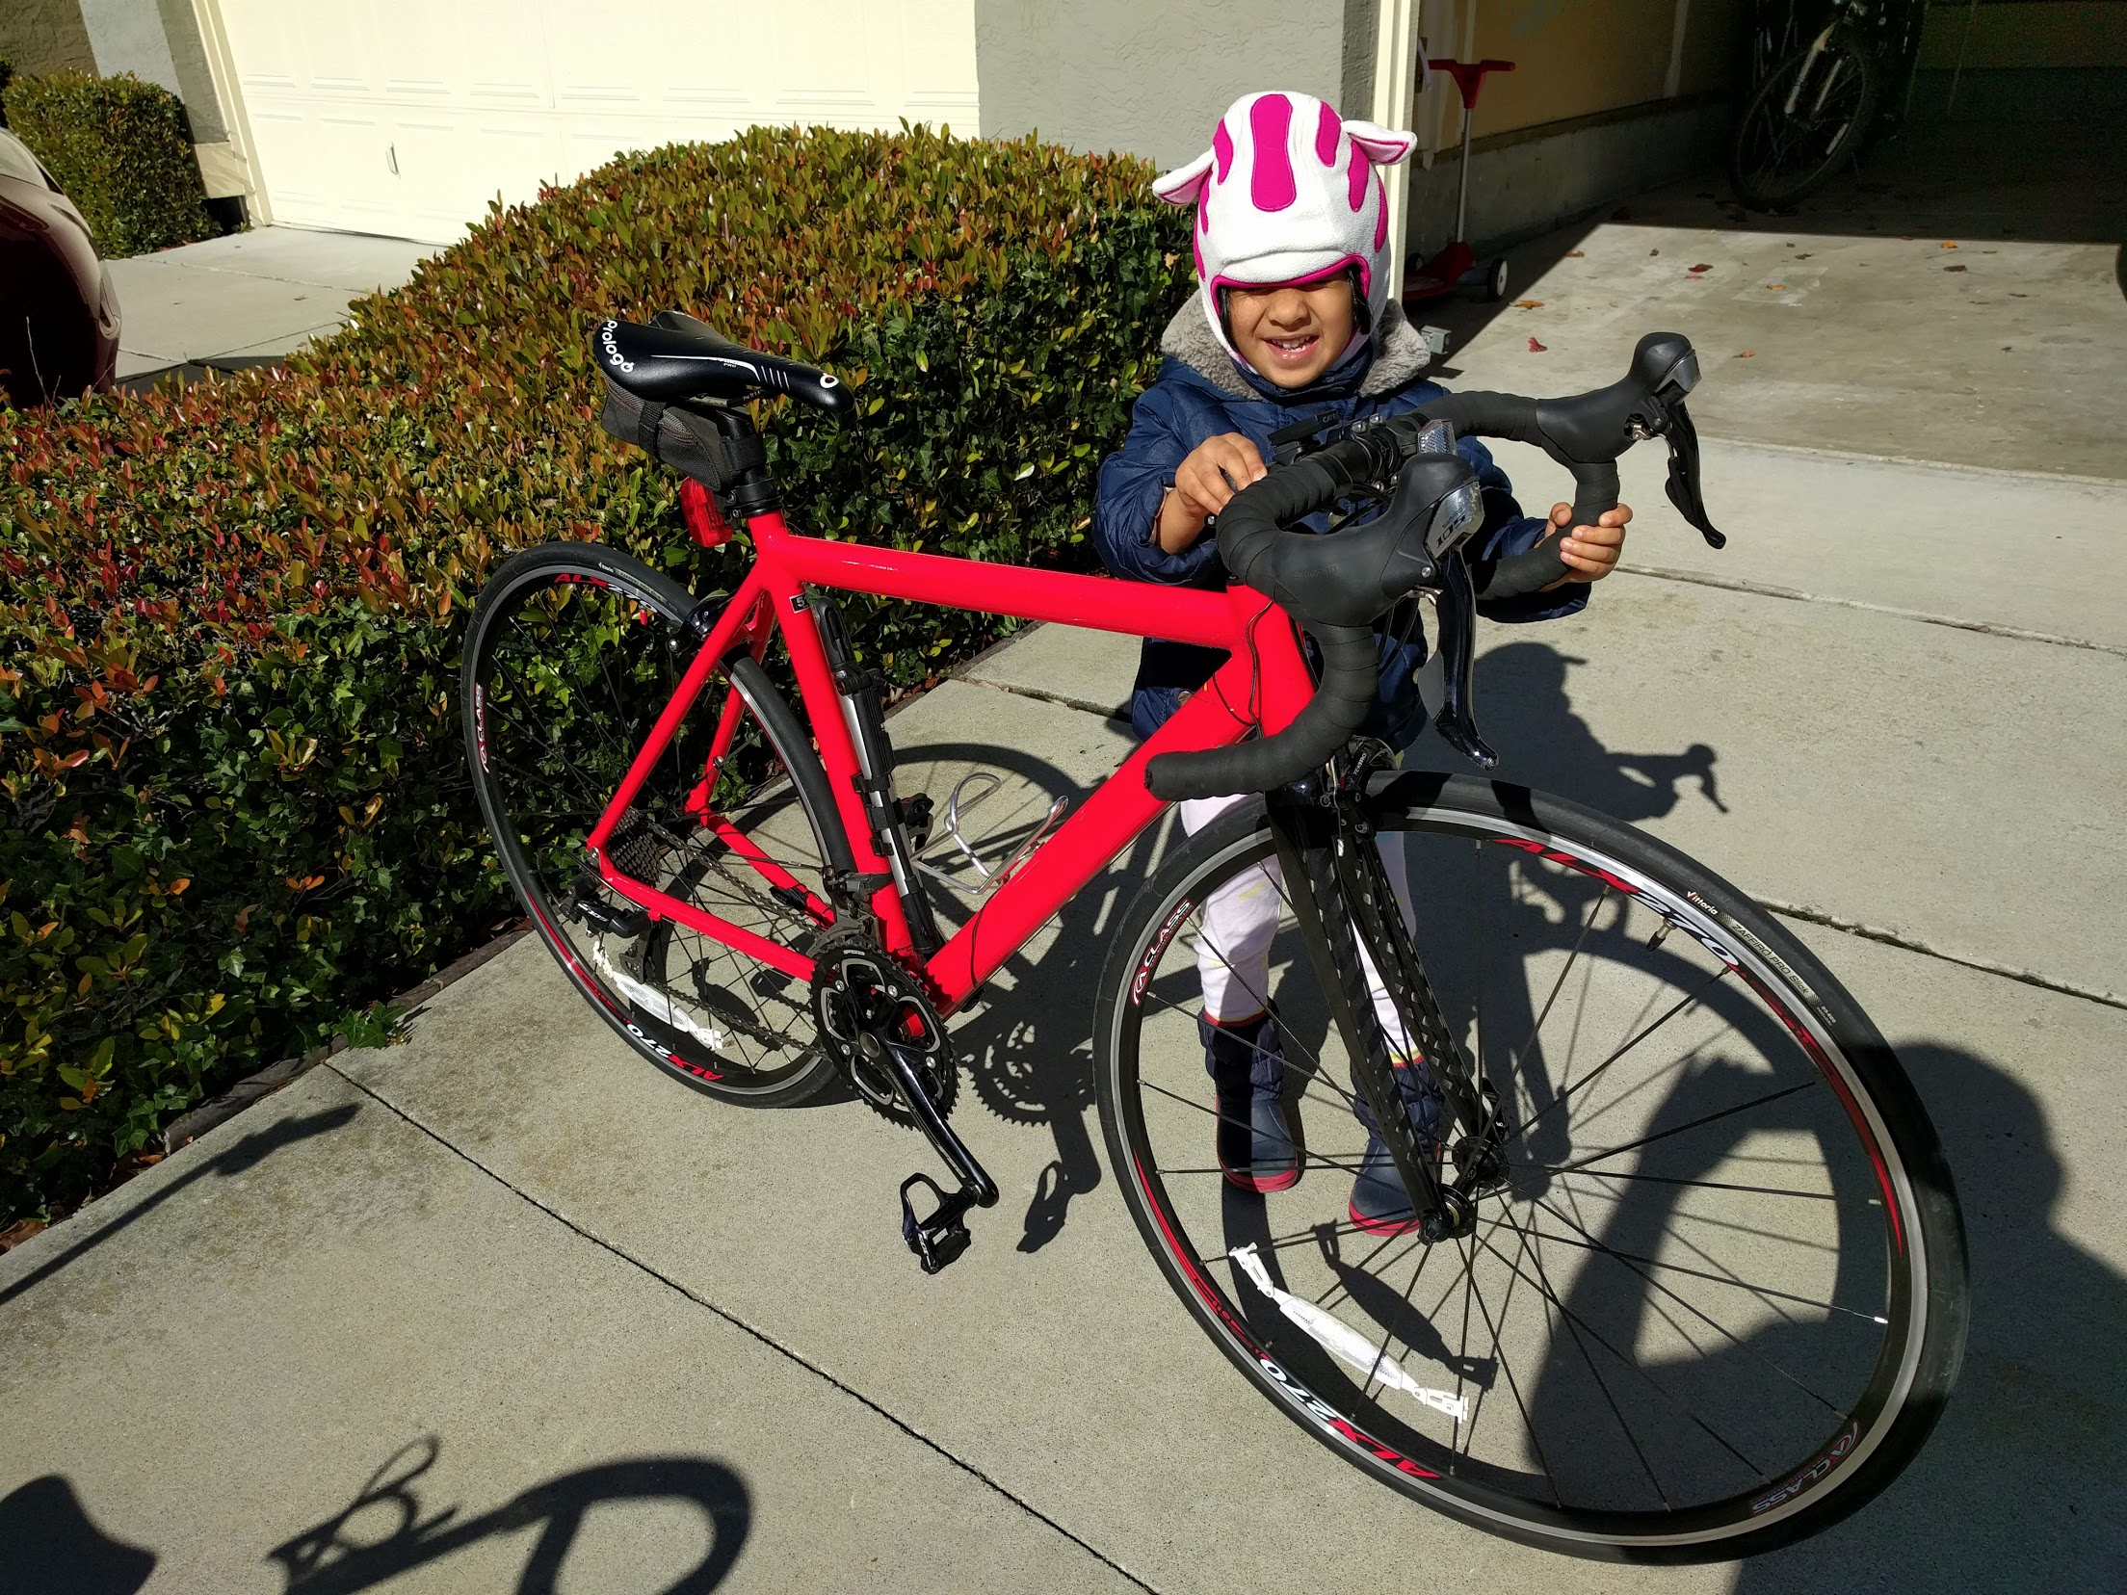
Avg cost : $1000+

The bike is just a beginning and will need bunch of accessories to go along with it ..

- Bike Pump - Things will go wrong and we will need one and also have it handy helps a lot
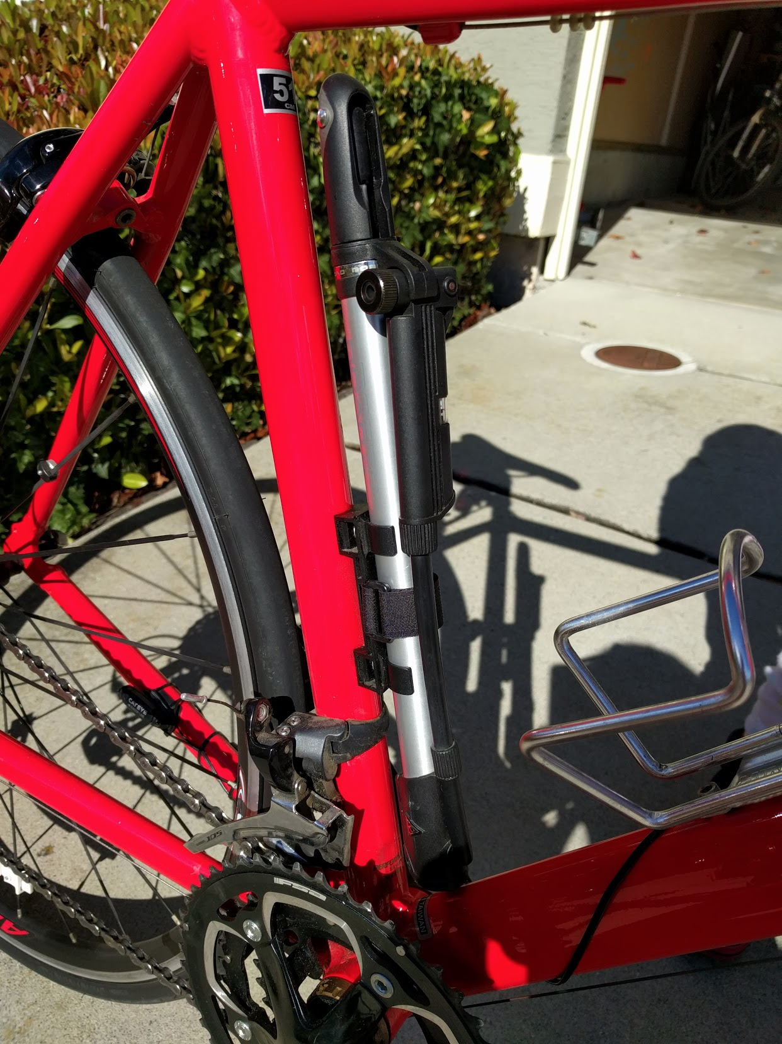
Avg price : $25+

- Bike pouch - It holds some basics needed like spare tube, clamps and a mini tool
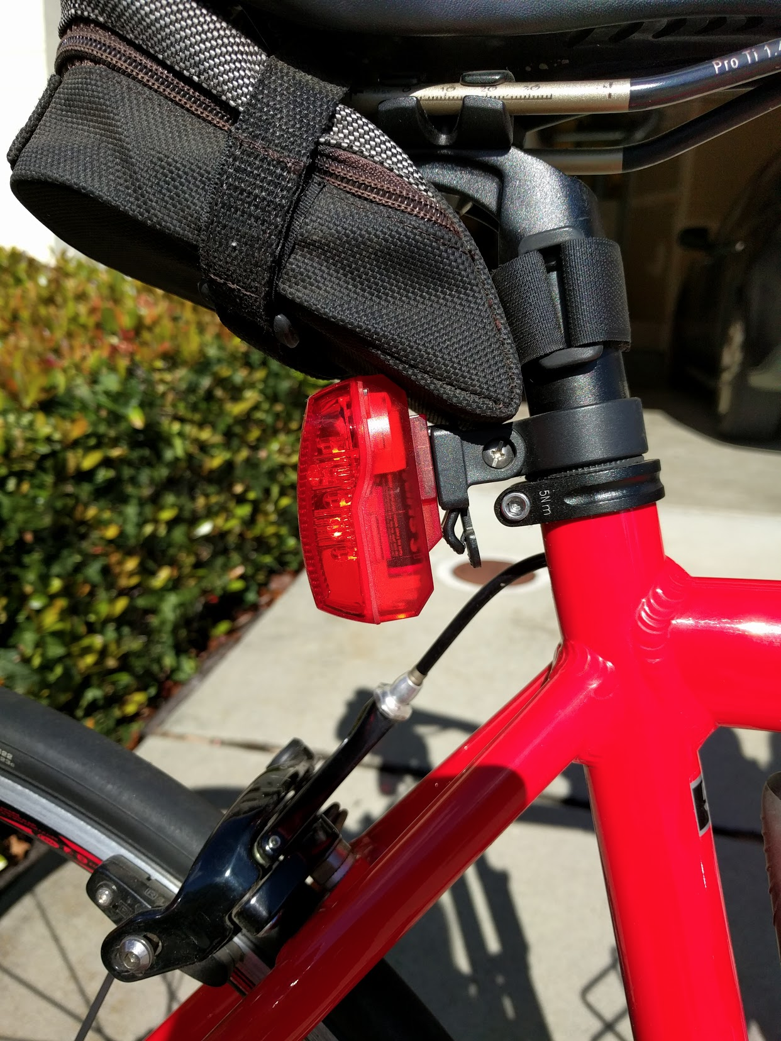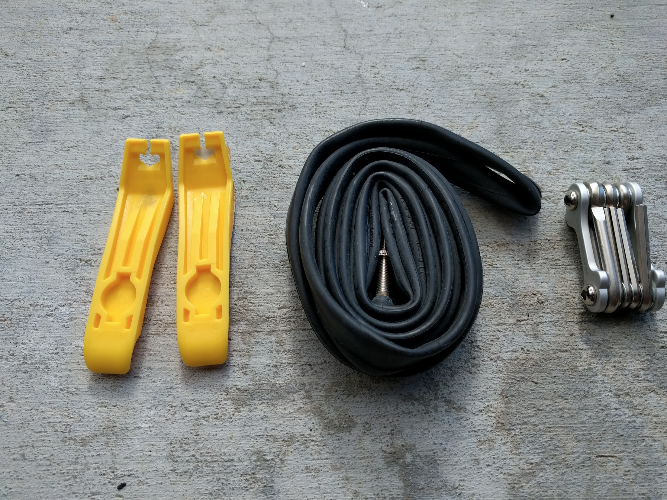
Avg cost : $25+

- Bike Back light - Needed for night rides and in general for safety purposes
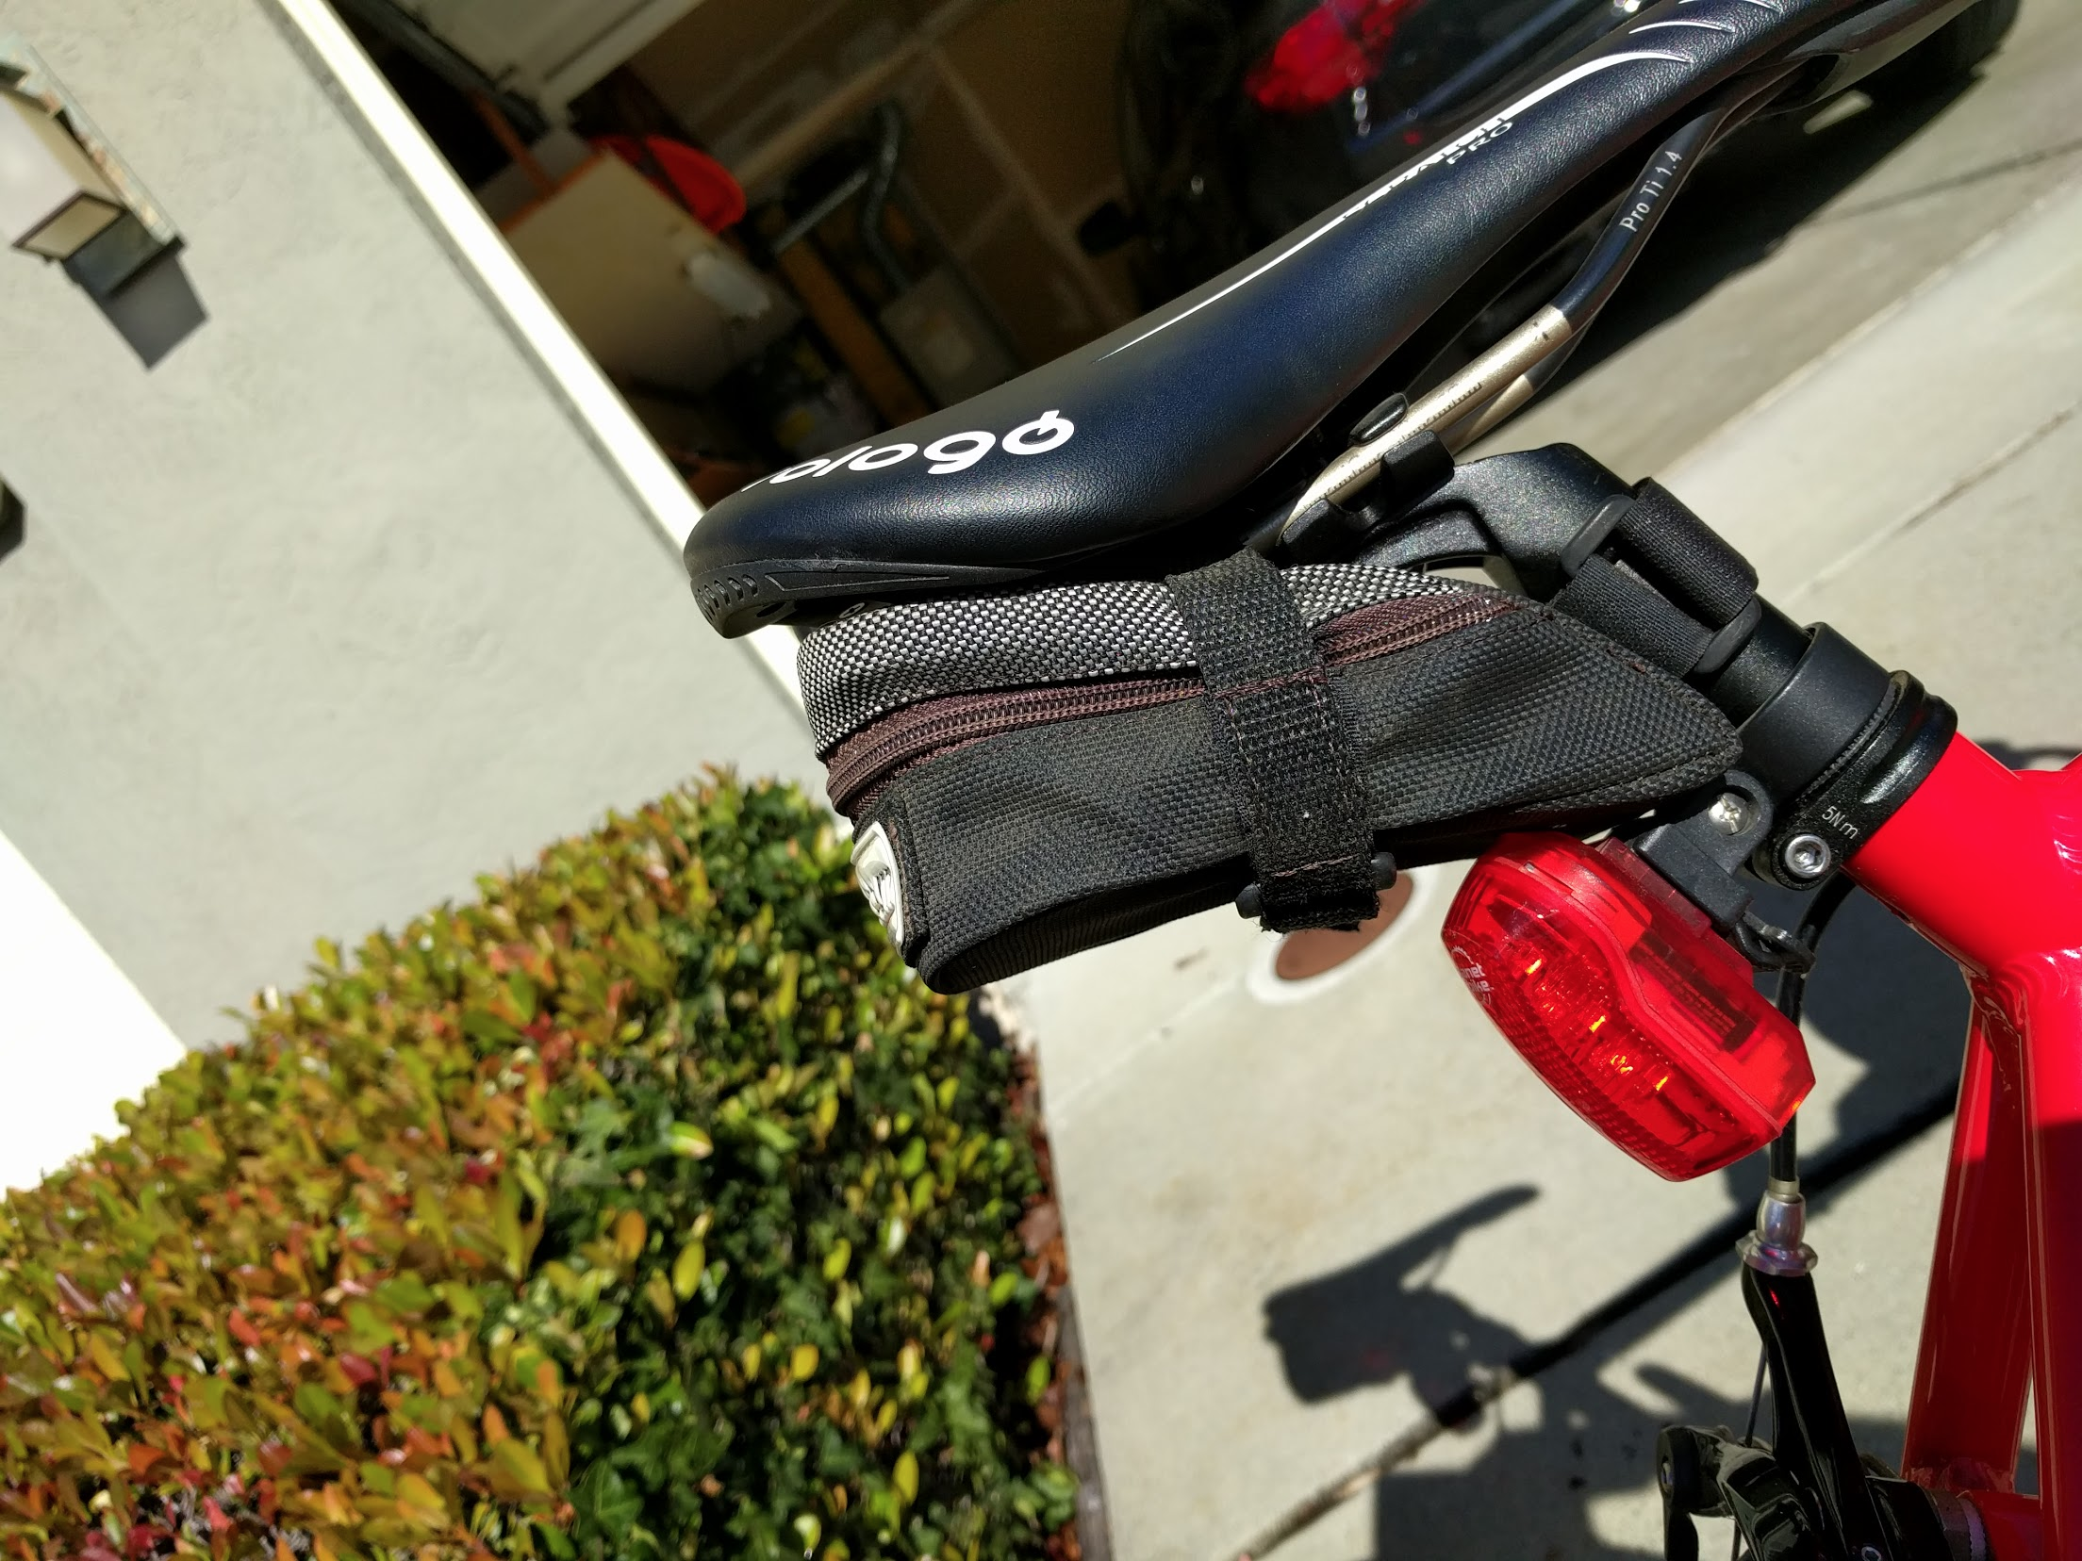

- Water Bottle holder - atleast one and two is not a bad idea
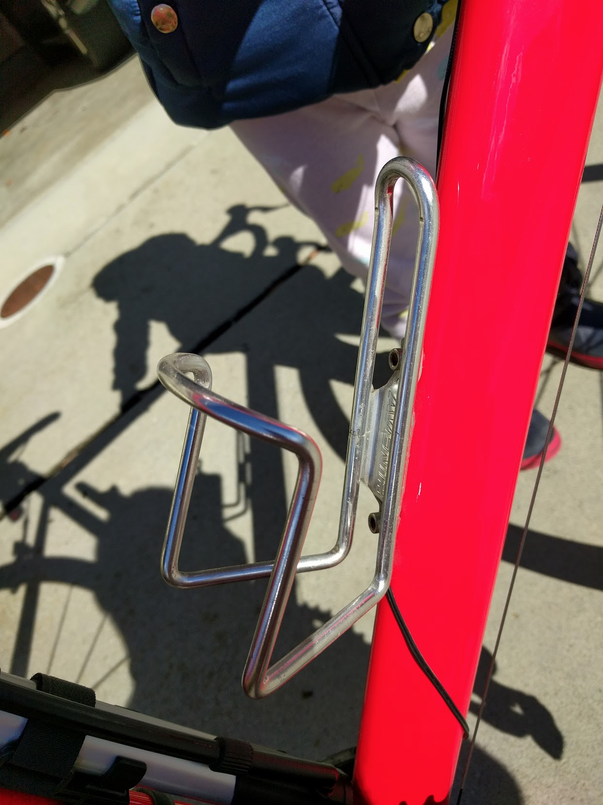
Avg cost : $10+

- Bike Computer - You need it to set and have a decent pace & for measurements, I prefer something that done not only the speed and distance but also the cadence. Cadence of the pedals are more important than the speed ..
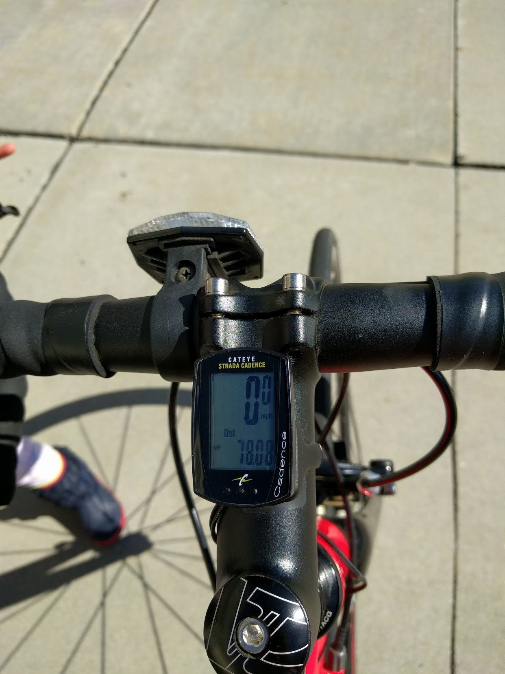
Avg Cost : $100+

- Pedals & Shoes - also called as clipons and it really important to get used to it for long rides where you no only push but all push for maximum transfer from legs to the bike ..
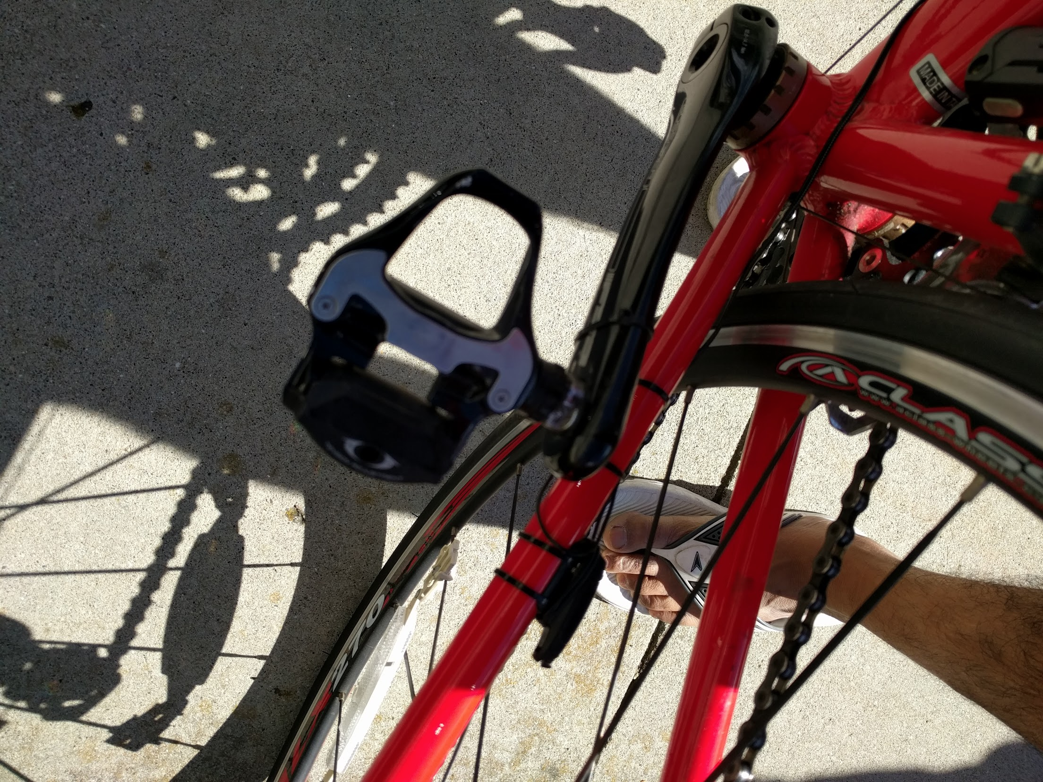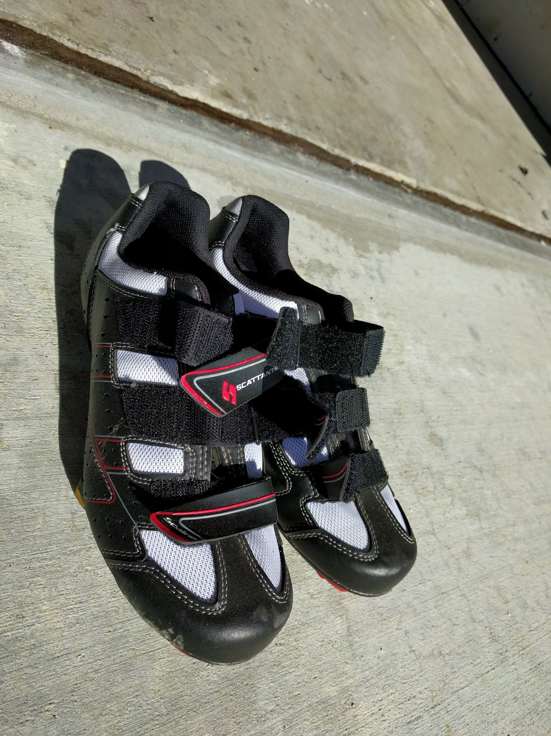
Avg cost : $125+

- Saddle - You will sit on this for really loooooong time. Make sure to get a really really comfortable one. It hard to find the right one .. be prepared to purchase or swap
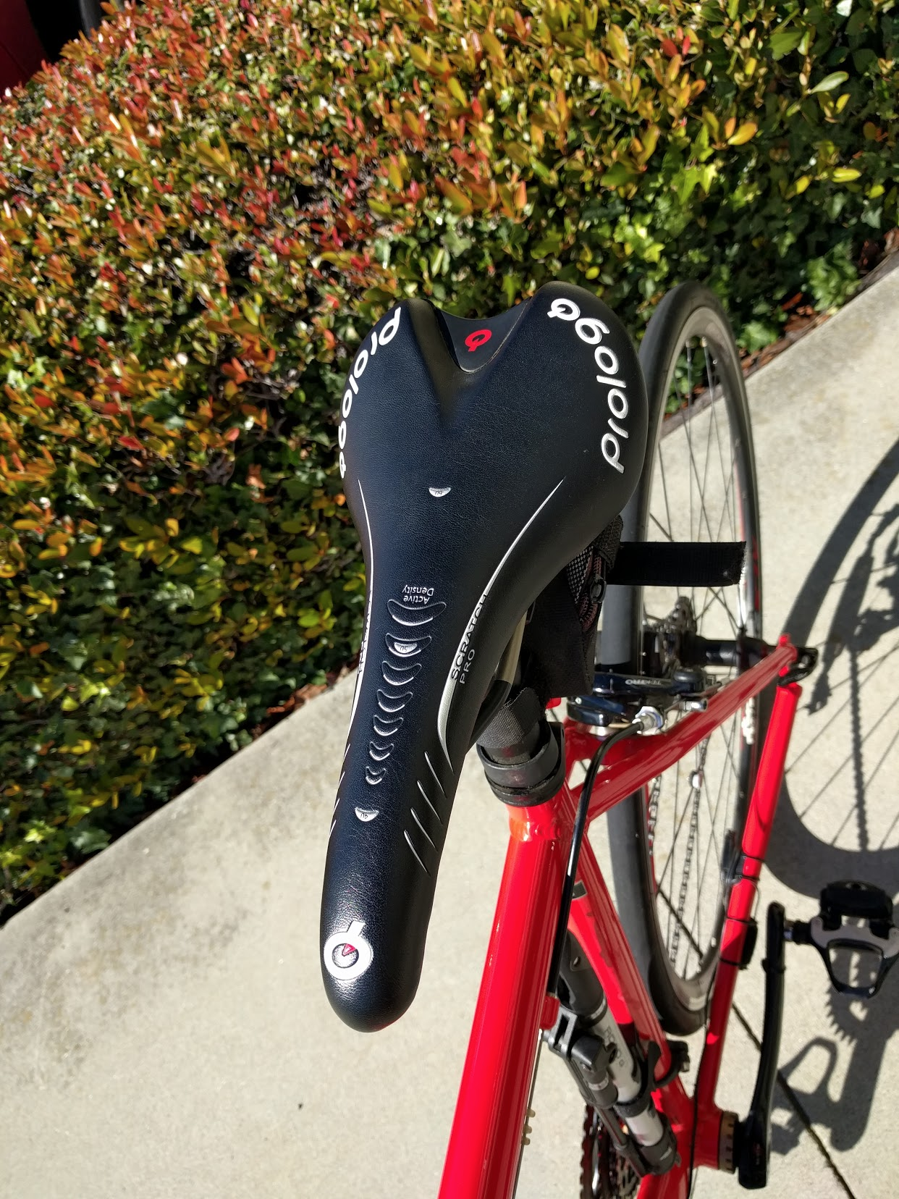
Avg cost : $50+

- Clothing - There is whole range of stuff that we can get and you can slowly add over time, but the key ones are - gel padded shorts, nice rider shirts with pouches, hand warmers, head sweat absorber, and really good bike gloves
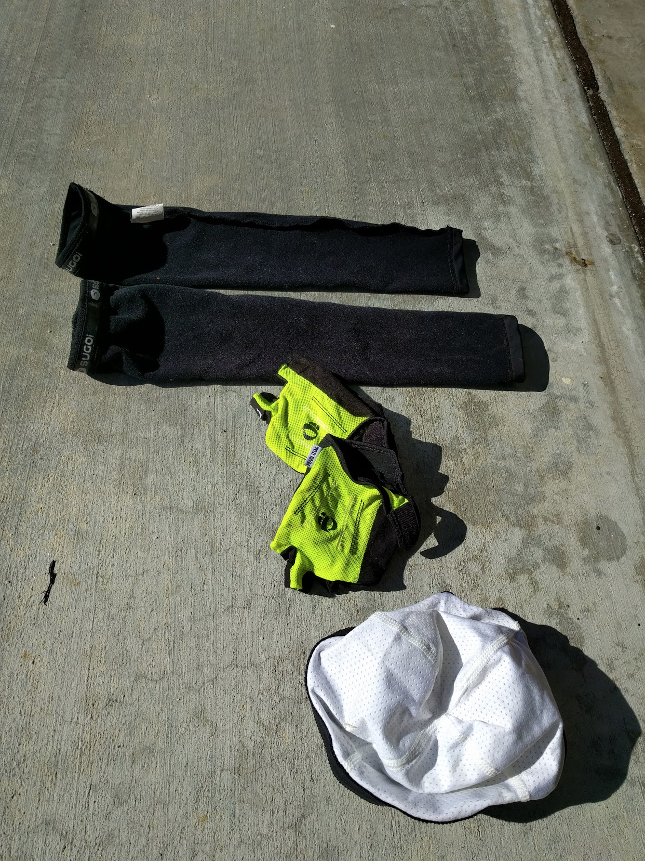
Avg Cost : $50+ (shorts), $50+ (bike shirts), $30+ (hand warmer), $20+ (head bands), $30+ (gloves)

- Helmet - very important for safety, and make sure you buy one that is comfortable
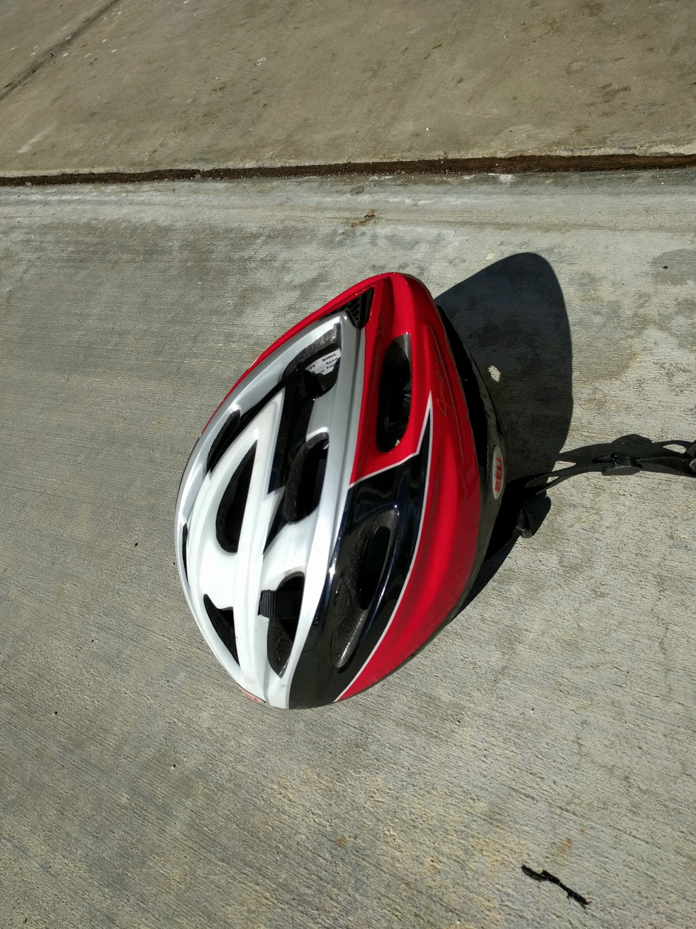
Avg Cost : $30+

- Heart Rate Monitor - Along with cadence, it is extremely important to ensure that the heart rate is steady to prevent overdoing it
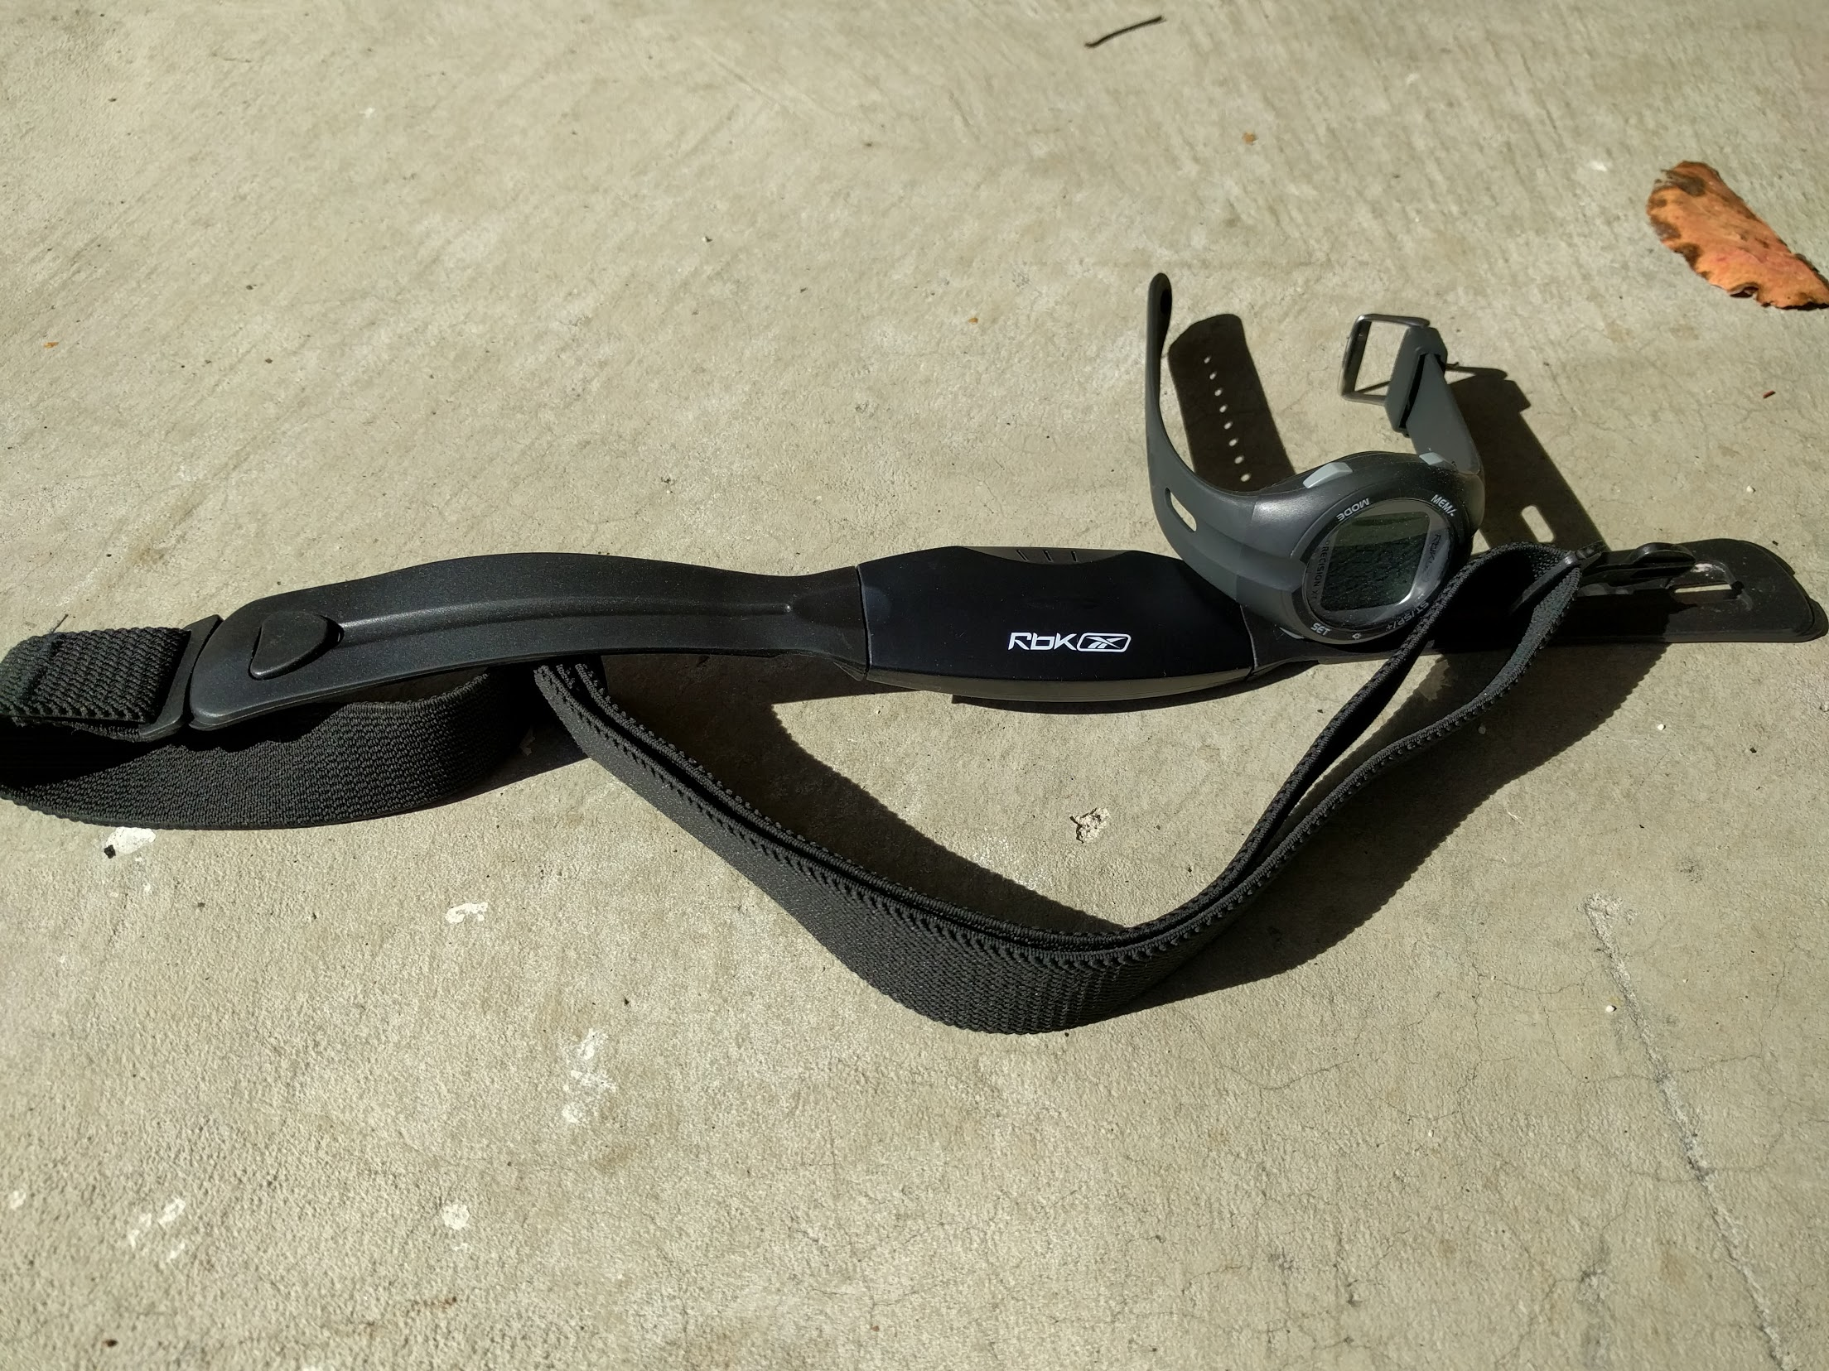
Avg cost : 50+

