10/24/2021 BMiller

1. General structure of Tables on website

We are a WordPress based site. WordPress uses MySQL to manage all of its data. All WordPress tables in MySQL (as far as I can tell) are labelled in the form “wp_*”. For example, the users table is “wp_users”.

Most of our FFBC specific data is stored via Form entry applications from the SW provider Formidable Forms, into tables designed to work with their applications. Their tables are labelled in the form “wp_frm_*”. For example their core data list is called “wp_frm_items”. Formidable’s Form entry program includes many different functions and features, but all revolve around a user initially entering some data via one of their forms.

We use the Forms application for FFBC membership, Member profiles, Primavera registration and ride list management, clothing sales, Cinderella coaching (in the past), Pedal Pounder entry and Pedal Pounder stats. All of that information is stored in the Forms subsection of the MySQL database (wp_frm_*).

1. Process flow for a person becoming a member

Before a person becomes a FFBC member they must first register on our website. ([Membership – Registration (ffbc.org)](https://ffbc.org/membership-2/membership-registration/) ). Once registered they can then join the club by going to <https://ffbc.org/membership-2/update-renew-membership/> to create a membership or renew.

The first step above uses the WordPress tools to register on the website. As a result this information is stored in the WordPress portion of the database, in the tables wp_users and wp_usermeta.

The second step, becoming a FFBC member, uses the Forms tools from Formidable. As a result the membership information is stored in the Formidable portion of the database, the tables wp_frm_items and wp_frm_items_metas.

1. Membership tables used on our website

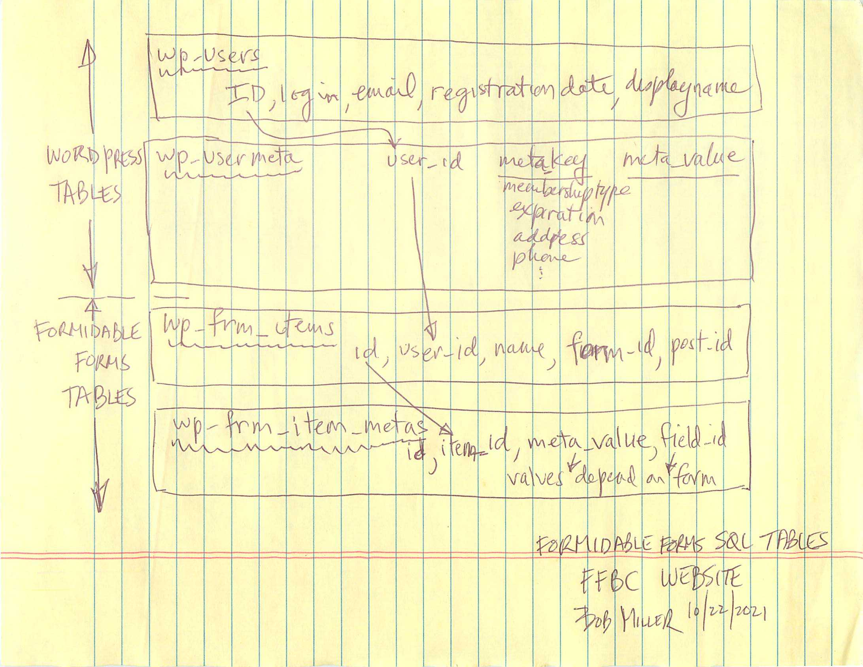

* 1. wp_users

This is the fundamental registration and membership table. It is a WordPress generated table. When a person registers, an entry is created in this table with their name, email, and registration date along with some other login info. Most importantly the entry also includes an ID. This ID is used in a number of other tables to associate this used with other table’s information. It is typically called the user_id.

* 1. wp_usermeta

This is also a WordPress generated table. When a person registers there is other miscellaneous info that is associated with that person. That information is stored in this table.

“Meta” is a typical term that you will see in WordPress tables. It means information indirectly associated with the ID (in our case the user who registered) in that table. Typically there will be a pair of entries – meta_key and meta_value. The first entry is a key usually defined by the particular WordPress setup (so it is programmable – an example might be “address”) and the second entry is the value associated with that key. This structure allows the WordPress setup to be easily be reconfigured as needed by the owner of the site. If you need two address entries, you can change our example of one meta_key for “address” to two meta_keys, one might be “address1” and the second might be “address2”. There will then be a meta_value associated with each of those meta_keys. Again these are stored by user_id.

* 1. wp_frm_items

This table is associated with the Formidable Form tool. It is one of their fundamental tables that provides an indexed listing of all entries into all Forms (membership, Primavera, Pedal Pounders, etc., in our case) along with reports and views that have been created, and many other capabilities of the Formidable tool. It has minimal information and is designed to be small and streamlined, with additional information meant to be in the following table.

In this table there is an ID (different than the one in the WordPress table), which is a pointer to that form entry (in other tables). So if a person creates a membership, there will be an ID created in this table that is used to point to all the information related to that membership creation. In many views and reports this ID will be called EntryID. Every form entry that is done on our website will have a unique EntryID (ID) associated with it.

For each entry there is also a user_id (linked to the ID in the wp_users table – so the entry is associated with a specific user), a name (the person’s name who created the entry – somewhat redundant), a form_id (tells what form was used for entry – membership form, pedal pounder form, etc.) and a few other misc. items.

* 1. wp_frm_item_metas

This table is tightly linked with the wp_fm_items table, just as the WordPress wp_usermeta table is associated with the wp_users table. In this case, the wp_fmr_item_metas table has additional meta information associated with each form entry that is defined in the wp_frm_items table.

As we saw in the wp_usermeta table, this table is basically a list of meta values. The meta values are indexed (linked) by the EntryID from the prior table (wp_frm_items). There may be more than one entry per EntryID, because there may be more than one entry value per form (typically this is true).

The important values in this table are field_id and meta_value. Field_id is a meta_key value that matches to an entry in the user entry form. The meta_value is the value associated with that field entry. For example a phone number is field 510 in our membership entry form. So an entry into membership form might include a field_id=”510” and a meta_value=”510-123-4567”. Again these are all linked via the EntryID, which will be a specific entry done by a user at a specific time.

1. Summary

Fundamental to everything happening within a WordPress site is the MySQL database that stores and manages all of the data associated with the site. The data can be provided by web and theme vendors to describe how the site should look. Additional information is provided by Plug-In vendors (special apps to add functionality to the site. Formidable Forms is one of them). Finally there is data logging of information that users enter into the site, in our case, typically via our forms entry.

WordPress provides a user_id that is used to track which user is entering what information. And in our Form Entry functions we also have an EntryID to track each individual entry that a person (user_id) creates.

In our membership “table” (it’s a virtual table inside the wp_frm_item_metas table), there is an entry for every renewal for each member. That entry is created when the person renews, and is not changed after that point. That entry contains their contact info at the time of renewal and is frozen in time.

When a user modifies their contact info via the Profile page (<https://ffbc.org/membership-2/membership-profile/>) they are changing information in the wp_users and wp_usermeta tables.

There was a bug discovered recently with the membership expiration email sent to members. It was using the email address from the membership “table” not in the wp_users and wp_usermeta tables. Hence it was potentially using old information. That was recently corrected.