FFBC: Managing, Viewing, and processing Clothing orders 2/9/2017

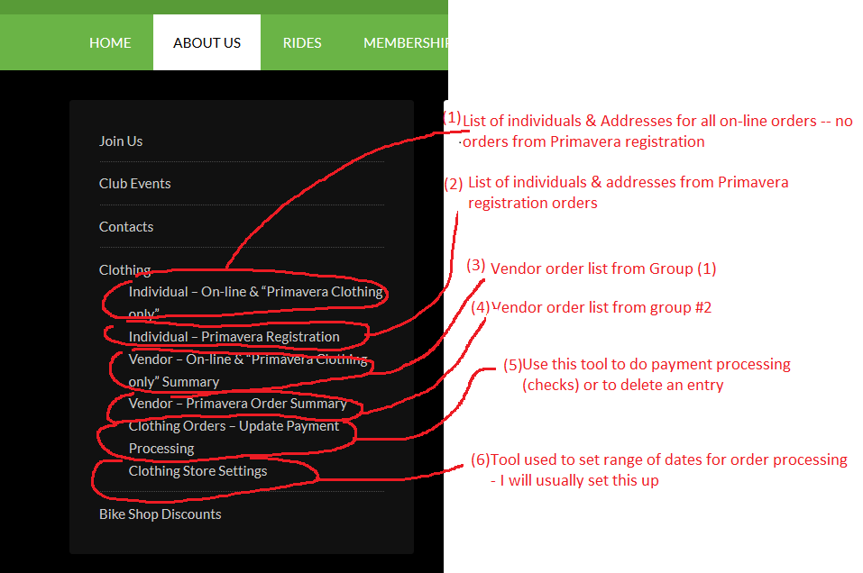

You will use #1 & 2 for creating your mailing lists

You will use #3 & 4 to create the quantities you need to order from the vendor

5 will be used to process checks (I haven’t seen any yet)

6 is for setting the date range that is used for the orders. I will manage this for the time being.