If you have lost your password or can’t remember your login take the following steps:

1. Go to the FFBC website member login: <http://ffbc.org/membership-2/member-login/>
2. There you will see:

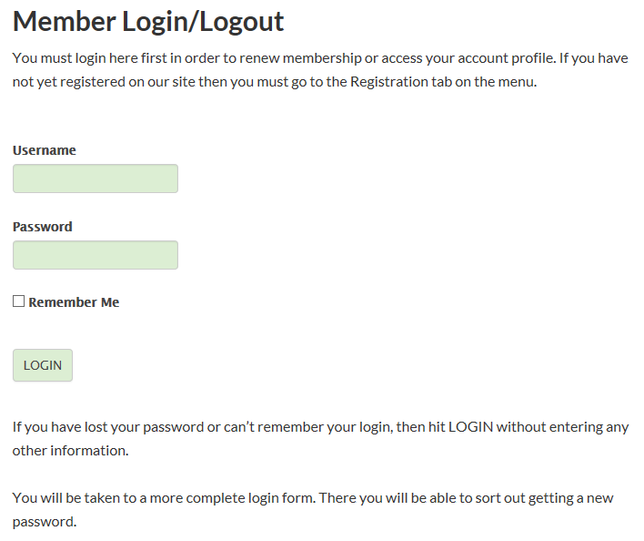

1. Don’t enter any information, just click LOGIN. It will take you to this view:

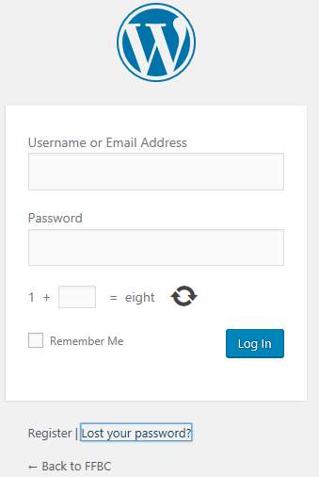

1. Click on “Lost your password?”

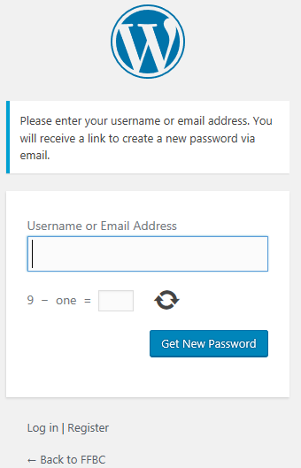

1. You can enter either your username or email address
   1. For our members that had their user name and password sent to them when the new website was setup, your user name is normally the merging of your first and last name, with capital letters used for the first character of your first and last name. For example: The user name for John Doe would be: JohnDoe
   2. Otherwise enter your email address that was used on the old website or for the FFBC_List.
2. Answer the math question and click “Get New Password.” It will update with the message “Check your email for the confirmation link.”
3. The email will go to whatever email address is associated with your account – typically the same address you get your FFBC_List messages at. The email should look like this:

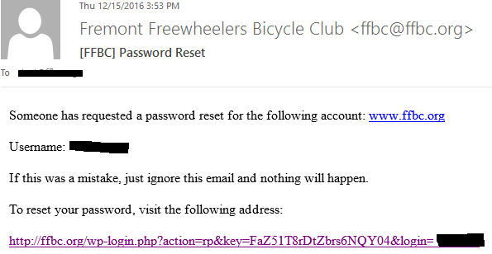

1. This email will have your username (if you weren’t sure). Click on the link and follow the instructions on updating your password. Make sure that you select a strong password. If you don’t you will have to enter your login credentials twice every time you log in.
2. In the future you can update your password (and other contact info) by visiting the Member Profile page at: <http://ffbc.org/membership-2/membership-profile/> . **Most importantly however, you can view your membership status there.**