Posting to the FFBC website

Below is a description on how to Post, using a “minutes” posting as an example. The difference would be the category you select at the end (item #4 in the picture and description). That determines how it is sorted on the “News/Links/etc.” page. You can look at the categories I have created and decide which is the best fit. Or we can create a new category.

All posts appear on the home page of our site in the bottom right corner. There is one other attribute you can change if you would like a post to “stick” on the front page. I.e. as more posts get added, normally the posts roll of the bottom of the page. But the sticky ones don’t. You can change that under the “Status: Publish – edit” entry just below my #6 in the picture below. So that might be useful for special announcements like a club party, for example – you can keep it at the top of the list. But… you do need to remember to remove it after the event has passed.

In the example below I describe how to add a link to a PDF file into a Post. Similarly you can add any kind of media into a Post – pictures, videos, or whatever. You would do it in the same way as adding the PDF.

***********************************************************************************

Once you’re ready to publish (or Post as it’s called) the minutes into our website blog, you do that by going to the Posting area of our website. I have given you special privileges associated with your login which allows you to get to the Posting area.

You can go to the link:  <http://ffbc.org/wp-admin/edit.php>

 You will be asked for your username and password if you’re not already logged in.

When you get to the site it will look like this:

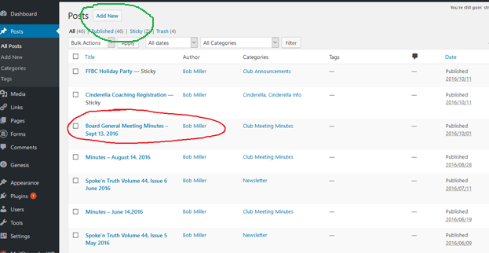

These are the Posts that appear on our webpage (as of Oct 11, 2016).

 You can click and select my last minutes posting or any later minutes posting (circled in red above) to see how I did it last time. It would look like this. Note that all posting have this same look, it’s only the content that is different.

Remember the green button above. That’s what you’ll select when you are ready to enter your Post.

Here’s what the Sept 13th minutes look like. Any later minutes will look similar, just the ontent will be different.

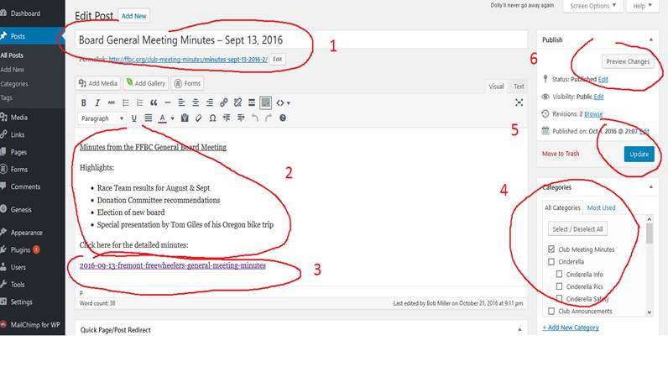

 You’ll want to use is as an example.

 So go back in your browser to the “Posts” page that lists all the posts. Select “Add New” (circled in green two pics above).

You’ll go into a blank post. Following the numbered list in red above, follow the numbered list below (numbers match):

1. Enter the post title – typically like I’ve done in the example, but you’re welcome to create your own “standard”.
2. Add a little text and highlights of the meeting. This is the text a person will see on the first page of our website – use it to get people to read the entire set of minutes.
3. Here’s where you upload your PDF minutes. Put your cursor where you want to add the link. Then click the “Add Media” button above the text editor box. You’ll see this window:

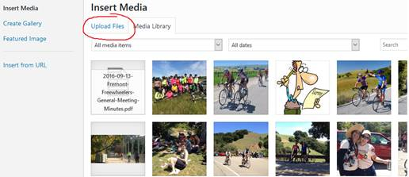

Select “Upload Files”. You’ll see this window:

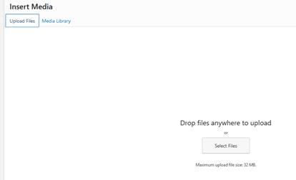

Click “Select Files” and upload your file. You’ll immediately go back to the original window and see that your file is there and selected (mine was named “form_50.txt”)

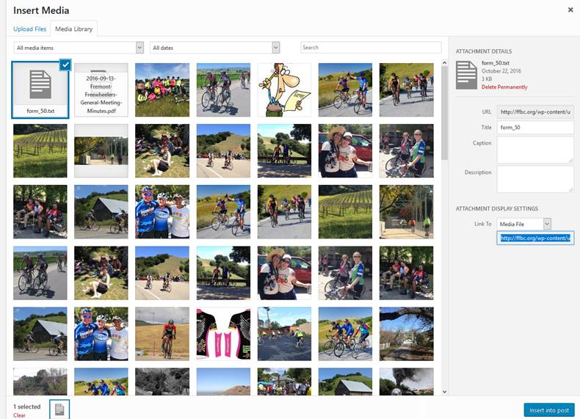

Click button on bottom right called “insert into port”. You’ll immediately be taken back to your Post with the link inserted.

1. Next you select the category that the Post will be displayed under. This determines what menu items it shows up under. This is important to get right. Since these are club meeting minutes, check “Club Meeting Minutes”. For other Posts review the list of Categories and pick the most appropriate one.
2. Where my picture shows “update” when you first create the Post it will say “Publish”. If you’re ready to publish and you like what you’ve created you can click this button and you’re done. If you’d prefer to do a preview then select the “preview” button shown as #6. Or there’s another button in the upper right not shown on my example: “Save Draft” Click if you want to save your work and come back later.
3. Click to Preview your work before publishing.

After publishing you can go to our FFBC website and your Post should appear on the bottom right under “Club News and Info”.