Prior to us getting a transfer request, the buyer and seller should follow the instructions at the Tranfer tab in the Primavera menu. The recommended approach is:

1. Buyer registers on-line as a Transfer entry. Buyer gets an email giving them their Registration ID.
2. Seller fills out form, puts in their Infor and Registration ID along with Buyer info and Registration ID.
3. Seller sends form in
4. We then run the tool and enter that info, and processing is done. At that point an email is sent to the seller and buyer notifying them of the transfer completion.

The special case is if the buyer just fills out the mail-in form (versus registering on-line). I recommend that we then manually register the buyer at our end, and process from there as normal.

If the Transfer was submitted with a mail-in form for the second rider, it’s recommended that you manually register that second person on-line. Where Payment Method needs to be chosen, select “Transfer”. Then go to the Committee – Registered Rider List. Look up the second rider. The ID field is the Registration ID for that rider. Save that for the Transfer process below.

To execute the tool do the following:

1. Login (as committee member – this will allow you to see the special committee menus)
2. Go to Primavera page and select “Update Rider Status-…” Under the Committee menu item.

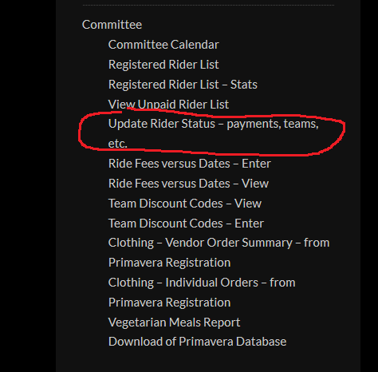

1. The first dropdown selection is “Operation”. Under that select “Transfer”.
2. New entries will appear after you have selected Transfer. It will look like this:

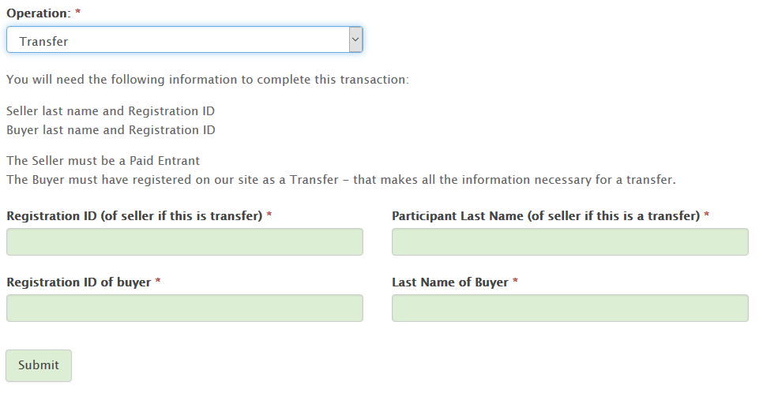

1. Fill in the 4 fields. The riders should have submitted their Registration IDs (or Entry IDs) (See above if the second rider provided a mail-in form). Enter that and their last names in the fields.
2. If the information is correct and the last names match the registration information, the transfer will be processed. Otherwise you’ll get an error message describing what the issue is.
3. Once the transfer is processed it will send an email to both the seller and buyer indicating the transfer is complete.