Website: manual membership entry – done by the director of membership

Setup Dir of Membership with Admin privileges. Their password then becomes a universal password.

To do this I have setup a new account for you with username “AdminLogin”. Keep this password very safe and if you ever change it make it a good password.

More important than the account is that the password will allow you to log into anyone else’s account (accept other Admin people). You just substitute your password in place of theirs.

To do that you need the person’s user name. For example Paul Arvin. Every person I have setup on our system has a username which is their first and last name concatenated together. So Paul’s username would be: PaulArvin. Newer members may not have followed that standard. To find their username you need to login as your AdminLogin and go to the dashboard, and the Users section:

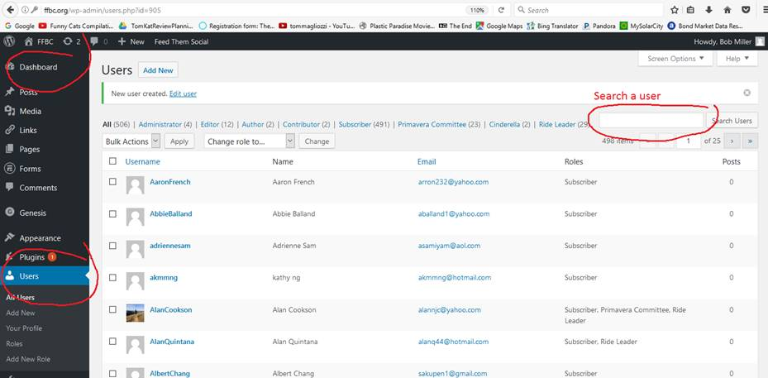

I can show you more about that later.

 One note – your AdminLogin user login gives you total privileges to do anything on the website, even delete it all. So be very careful and only login when you absolutely have to.

 Back to membership stuff for a user:

1)      Find their Username.

2)      Login as their username, but use your AdminLogin Password instead of theirs..

3)      Once you are logged in as them, you can go to membership renewal.

4)      Since they are already members, it should all be filled in (except for age – I suggest just guessing – it’s more for our use anyway and we’re not using it at the moment)

5)      Do a final submit – which in all the mail in cases will be a “Check” payment.

6)      And you should be done.